Lab 8

8.1 Write the output of the class given below.

from abc import ABCMeta, abstractmethod
class Super(metaclass=ABCMeta):
def delegate(self):
self.action()
@abstractmethod
def action(self):
pass
class Sub(Super): pass
>>>X = Sub()

Output
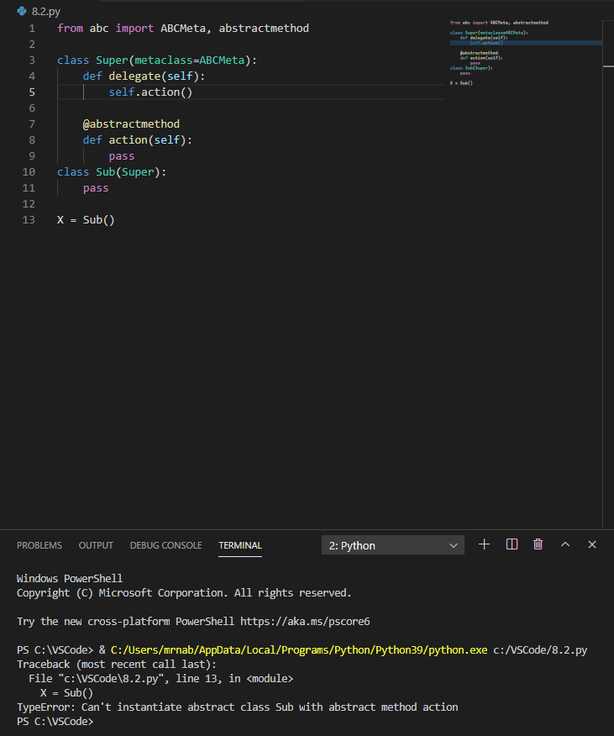

8.2 Modify the program given in Exercise-1 to remove the error. Write program and its output.
Source code
Output
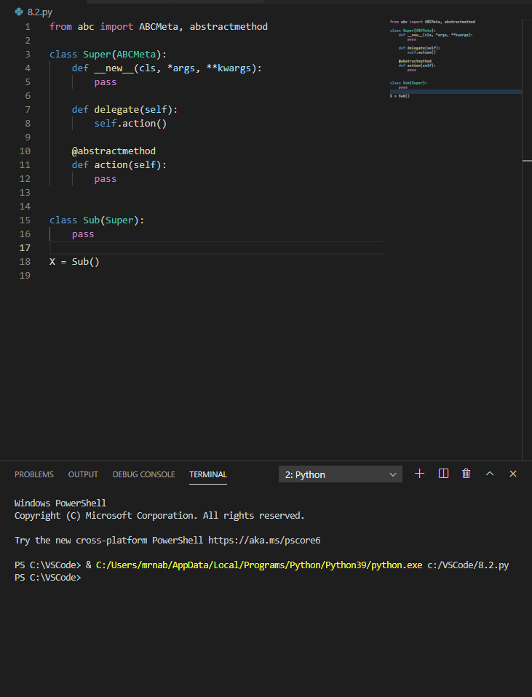
8.3 Develop a class that covers two common properties / variables along with two distinguishing properties of each of the vehicle (car, truck and motorcycle). Define separate class to cover the unique properties of each of vehicle type. Use the concept of inheritance and abstraction to implement the program. Define print function to print the output of each class.

Source code
from abc import ABC, abstractmethod

class vehicle(ABC):
tires = "Tires"
rims = "Rims"

def Print(self):
print("The Two common properties of all vehicles are that they all have", self.tires,"and", self.rims)

class car(vehicle):
doors = "doors"
small = "a small steering wheel"

def Print(self):
print("The two distinguishing property of a car is that it has 4", self.doors,"and", self.small)

class bike(vehicle):
helmet = "helmet"
handle = "handle"

def Print(self):
print("The two distinguishing property of a bike is that it has a", self.handle,"and requires a", self.helmet)

class truck(vehicle):
diesel = "Diesel"
big = "big steering wheel"

def Print(self):
print("The two distinguishing property of a truck is that it uses", self.diesel, "and has a", self.big)

nabeel = vehicle()
nabeel.Print()

rizwan = car()
rizwan.Print()

quadri = bike()
quadri.Print()

syed = truck()
syed.Print()

Output
